IDEATION PHASE
Empathize & discover:
An Empathy Map Canvas helps understand users’ thoughts, feelings, and actions when working with a system.
It is a useful tool to helps teams better understand their users.
Creating an effective solution requires understanding the true problem and the person who is experiencing it. the exercise of creating the map helps participants consider things from the user’s perspective along with his or her goals and challenges.
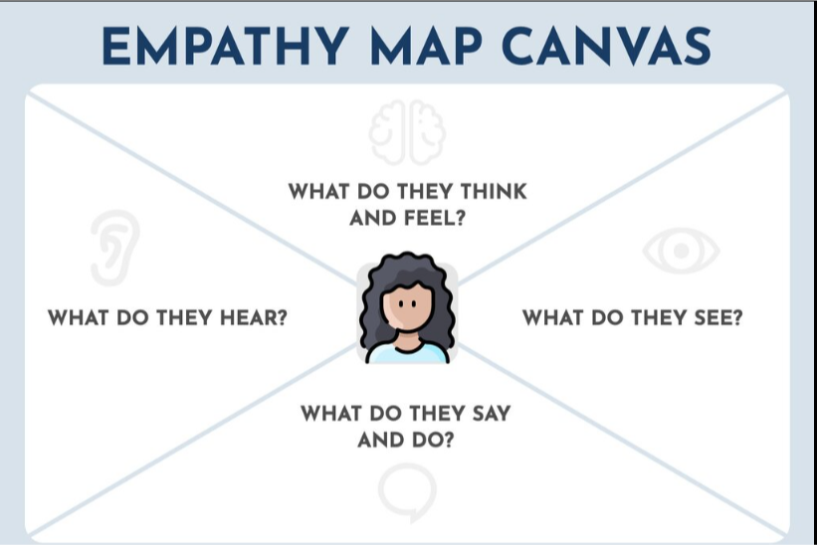

Brainstorm & idea prioritization template:
Brainstorming provides a fress and open environment that encourages everyone within a team to participate in a creating thinking process that leads to problem solving.
Prioritizing volume over value, out-of-the-box ideas are welcome and built upons, and all participants are encouraged to collaborate, helping each other develop a rich amount of creative solution.
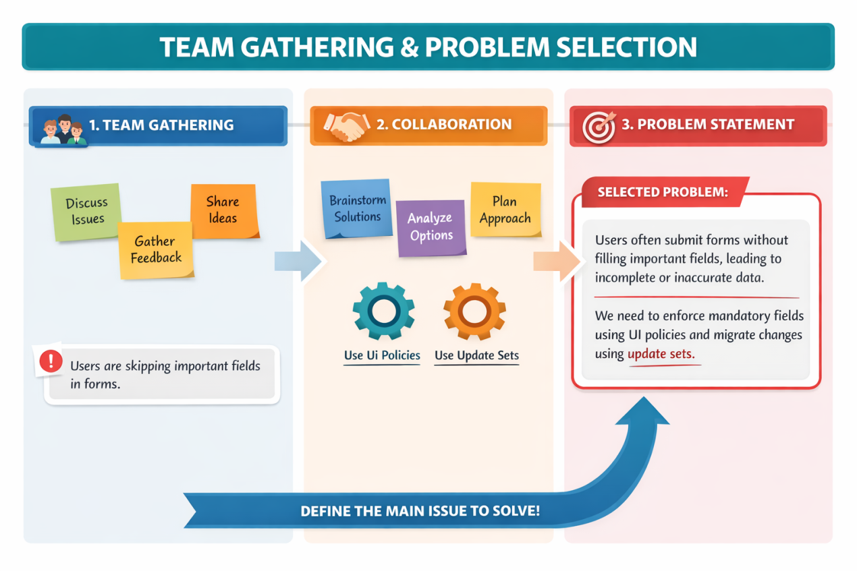

Define the problem statement:
Customer face issues when trying to delete users who are still assigned to active incidents. This leads to broken workflow and incomplete incident tracking.it creates confusion among team members who rely on accurate assignments records. delays in incident resolution can also impact service quality and compiliance.
